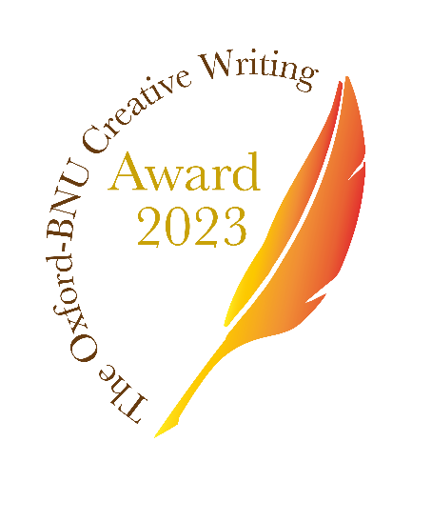

**Oxford - BNU Creative Writing Award  
Opening for submissions 1st October 2023  
Closing to submissions 31st January 2024**

**1st Prize £2,500  
2 Runner Up Prizes £500**

**For a short story of maximum 10,000 words in English prose**

**Eligibility**

* Undergraduate or postgraduate student on course as of date submitted in one of Oxford University’s 45 Colleges or Permanent Private Halls.
* Staff in any role, grade, employment status employed as of date submitted by any of Oxford University’s departments, colleges or permanent private halls.
* Must be the entrant’s original and unpublished work. One entry per author.

**About this Award**

The Oxford – BNU Creative Writing Award is offered by the Mo Yan International Writing Centre, based at Regent’s Park College and inaugurated in June 2019 to facilitate international and cross-cultural diversity within the global literary community. It is named for 2012 Nobel Laureate Mo Yan, who is an Honorary Fellow of Regent’s Park College.   
  
For the past two years of this award, we have been honoured to have Mo Yan serve as Chair of the Joint Judging Panels and delighted to have last year’s UK Panel judges, including Boyd Tonkin, Chair (2020 Benson Medallist of the Royal Society of Literature and Chair of the Man Booker International Prize 2016), Liz Trubridge (Executive Producer of “Downton Abbey”), Davis Bunn (Regent’s Park College), Lynn Robson (Regent’s Park College).

Competition and award management is the responsibility of the Mo Yan International Writing Centre, Oxford Prospects and Global Development Institute, Regent’s Park College, Oxford to whom all communications should be addressed at [pa_opgdc@regents.ox.ac.uk](mailto:pa_opgdc@regents.ox.ac.uk)

**Timeline**

* Submissions open on Sunday, 1st October 2023
* Submission deadline is 12 noon on Wednesday, 31st January 2024
* Shortlisted entries will be reviewed by the UK Shortlisting Judge Panel on 8th March 2024
* Final Judging Meeting will take place on 19th April 2024
* Award Ceremony will be held in May 2024 (date tbc)

**Submission requirements**

* Submit your entry as both WORD and PDF attachments by email sent from your Oxford SSO email address to [pa_opgdc@regent.ox.ac.uk](mailto:pa_opgdc@regent.ox.ac.uk) no later than 12 noon on 31st January 2024.
* The PDF version must be fully anonymised, named with the title and word count
* At the top of the WORD version state:

1. Your name as stated in your Oxford University matriculation/employment contract
2. Your name as you wish it to appear in any publicity, if different
3. Your email address for further correspondence
4. Your college, subject and year of study if a student
5. Your employing college/department and job title if staff
6. Your Bod card number

* Winning and selected shortlisted entries may be published by OPGDI or our nominated publisher and submission of your entry constitutes agreement to publication.