**Climate Change – Responsive Regulation**

**Regents Park College**

An inter-disciplinary dialogue between   
Oxford and Peking University students

30 June - 10 July 2025

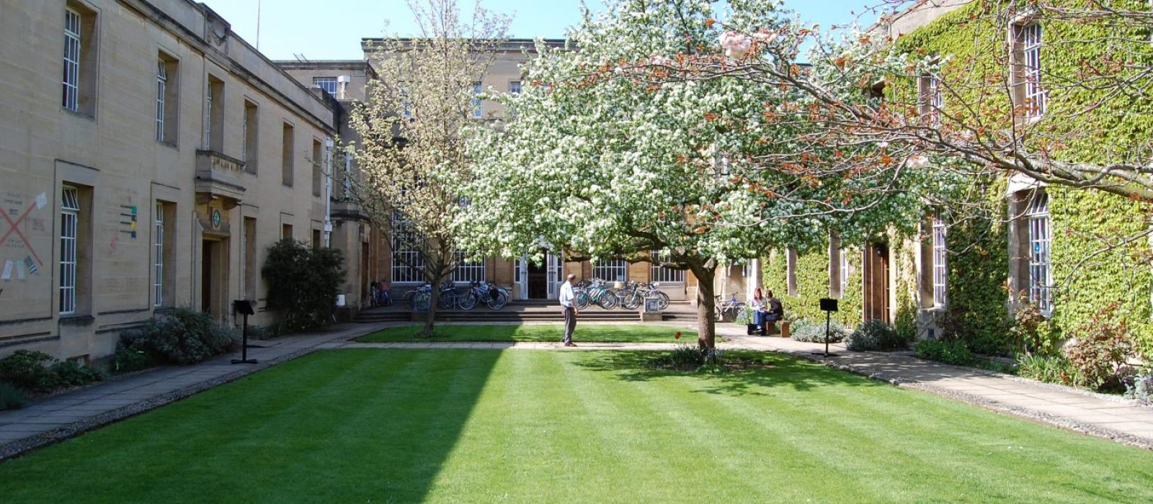

This workshop aims to bring together academic expertise from various disciplines to engage in collaborative discussions. It is a unique opportunity for students passionate about issues of climate change to dialogue with scholars and students from different geopolitical contexts and particularly to explore the legal community’s “response capacity” in addressing global environmental sustainability issues.

The workshop is co-designed and delivered by Peking and Oxford university academics specialising in issues of climate change.

Participation fee £250 (covers tuition fee and meals for the entire workshop)

Application forms must be submitted by 30 May 2025

For more details contact Dr Myra Blyth: [myra.blyth@regents.ox.ac.uk](mailto:myra.blyth@regents.ox.ac.uk)

**Application form for inter-disciplinary workshop**

**“Climate Change - Responsive Regulation”.**

**30 June – 10 July 2025**

|  |  |
| --- | --- |
| Name |  |
| Contact address |  |
| Contact e-mail |  |
| College affiliation within the University of Oxford |  |
| Subject/course/ faculty/department |  |
| Academic background and interests:   1. courses and qualifications already completed | |
| 1. your research interests especially related to climate change | |
| Briefly explain you reasons for attending this workshop and what topics/unique perspectives you wish to explore. | |
| What skills and related experience will you bring to this event? | |

**Please return this form to Dr Myra Blyth: myra.blyth@regents.ox.ac.uk**